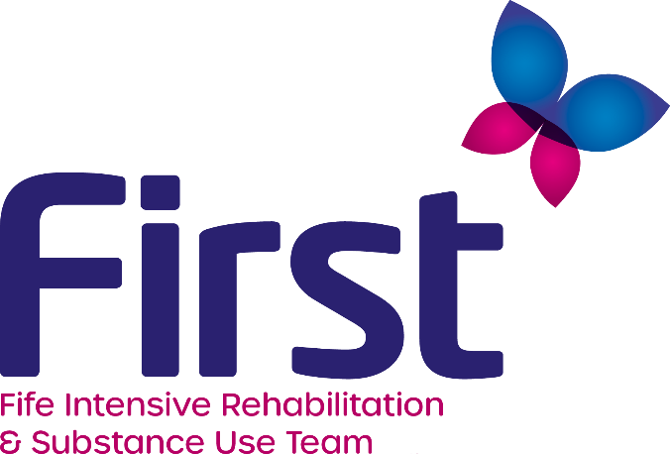

FIRST has a vacancy for a

REHABILITATION WORKER (GRADE B)
£24,309 - £27,312 (36 HOURS)

The Rehabilitation Worker will facilitate positive lifestyle changes for clients by developing and implementing individual Action Plans to enable clients to live predominantly without using substances.

Candidates should:

- be qualified to HNC in Social Care or equivalent OR SVQ3 Social Services and Healthcare at SCQF Level 7;
- have experience of working with individuals with issues relating to their drug and/or alcohol use;
- be computer literate.

The service operates on a Fife-wide basis therefore the ability to travel across Fife is essential.

FIRST operate a blended model of office/home working.

Application packs can be obtained by contacting jeanie.nowland@firstforfife.co.uk or downloaded by visiting our website www.firstforfife.co.uk.

Closing date for applications is Friday, 1st April 2022 at 12 noon

